***Smart Home Project using***

***Cortex M4 STM32F401TXve***

# Team Members:

1. Ahmed Ragab Hassan Tiba
2. Maged Mohamed Soliman El Naggar
3. Abdalhai Mohamed Tahoon
4. Abdalrhman Mohamed Mohamed Mostafa
5. Alaa Mahmoud Hassan Abdallah

# About:

* It is a popular project nowadays, it is a very comfortable application for humans, it aims to convert anything around to be controllable and smart.
* Project features:
* Remotely controlled by mobile.
* Locally controlled without mobile use LCD and Keypad.
* The controlled components are 5 lamps “4 on/off lamps, one dimming lamp”, door, air conditioner according to the ambient temperature.
* TFT is used to display the real time visualization of system
* Edit password at runtime.
* If entered passwords were wrong more than 3 trials, the system must break down and fire alarm then call police immediately.

# Specifications:

1. **Bluetooth & keypad**:

We can control system locally and remotely

* Keypad for controlling the system locally
* Bluetooth for controlling system remotely from any Bluetooth device.
  + Transmitting/Receiving between MC and PC/mobile.
  + Every action, Message must be printed on Mobile/PC screen.
  + Transmitting/Receiving the commands to run the system.

1. **LCD & TFT Displays:**

* Displays is used as an indicator for the user for each system stage.
* There are 4 main taps
  + Password tap
  + Welcome tap
  + Wrong input tap
  + Calling police tap
  + Password change
* After login, user can control all features.
* The interfacing of TFT displays the real time visualization and animation for each system component status.
* For future update we can use TFT as touch pad to control the system remotely.

1. **LED, & Dimmer:**

* There are 5 lamps “4 on/off lamps and one brightness controlled lamp”,

1. **Temperature Sensor, DC motor:**

* Temperature sensor reads the ambient temperature, if the temperature is higher than selected temperature, DC motor (Air conditioner) will run until it reaches the selected temperature.
* DC motor is Automatically controlled according to selected temperature at run time.

1. **Door:**

* a servo motor (Door) is used to control the opening and closing of the door.

1. **Password change:**

* It’s used to edit the user password through keypad or Bluetooth.

1. **System lock:**

* It’s used as a safety feature to logout from the system.

# Component involved:

1. Microcontroller STM32F401TXVE.
2. 24C08 EEPROM(Optional).
3. Bluetooth module HC 05.
4. LM35 temperature sensor or equivalent.
5. DC motor(L293D)
6. 5 LEDS.
7. Keypad, Lm01602A Character LCD and ILI9341 TFT.
8. Servo motor.

# Smart Home Flow Chart Diagram:

* 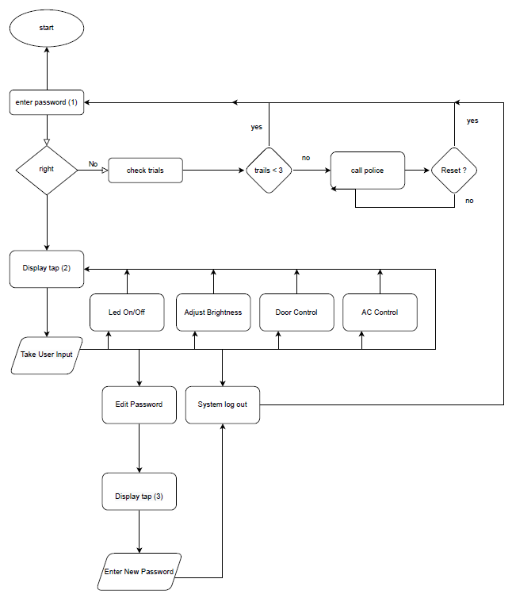This flow chart discusses the project and defines how the project is run.

# Protues simulation:

